# CS 255 System Design Document Template

## UML Diagrams

### UML Activity Diagrams

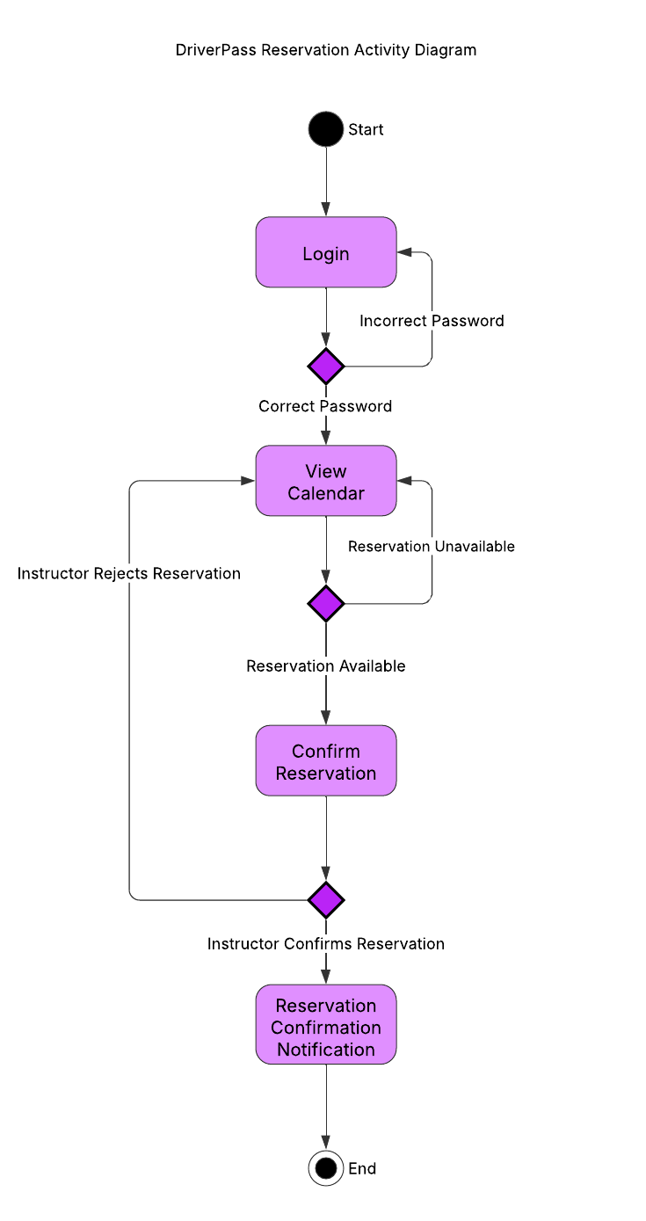

### UML Sequence Diagram

### 

### UML Class Diagram

## Technical Requirements

Hardware:

DriverPass requires robust servers to ensure smooth operation of the system. Cloud hosting infrastructure, which is secure and widely trusted, is ideal for this purpose. The servers should be equipped with sufficient storage, memory, and processing power to ensure 24/7 functionality with minimal downtime. Additionally, reliable network equipment such as routers, switches, and firewalls is necessary for secure data transmission and communication between the system’s various components.

Software:

The servers should operate on a stable and secure operating system that is capable of hosting web applications efficiently. A robust database management system (DBMS) is critical for handling and storing user data, reservations, and other system-related information. For the front-end, technologies like HTML, CSS, and JavaScript are necessary to build a responsive and user-friendly interface that dynamically adjusts to both desktop and mobile devices.

Tools:

Devs should use appropriate IDEs like Visual Studio Code or Eclipse, to facilitate efficient coding and debugging. Additionally, a tool like Jenkins should be implemented to automate testing, deployment, and general system maintenance, which could ensure continuous integration and consistent performance.

Infrastructure:

As per client requirements, cloud services such as AWS or Azure should be utilized for hosting the system, as they provide industry-leading solutions with low maintenance needs. Furthermore, it’s essential to implement monitoring tools and activity logs to track system health and security. This will allow IT to monitor operations and respond to any security threats or issues in a timely manner.